Life Membership : Rs.4000  Annual membership: Rs. 1000 | 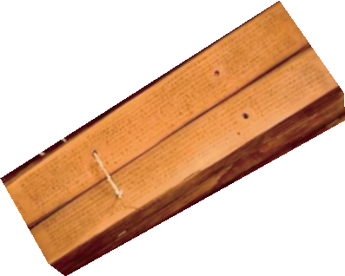 | Member Identity No.
MYCOLOGICAL SOCIETY OF INDIA
(Centre for Advanced Studies in Botany, University of Madras, Guindy Campus,
Chennai- 600025, INDIA)
APPLICATION FORM FOR LIFE / ANNUAL MEMBERSHIP

Name (Dr. /Mr. /Ms.) ……………………………………………………………………………..
Academic Degrees ………………………………………………………………………………..
Designation …………………………………………………………………………………………
Address
Official…………………………………………………………………………………………………………………..………..……………………………………………………………………………………
Email …………………………………. Telephone………………….. FAX…………………………
Mobile…………………………………….
Permanent
…………………………………………………………………………………………………………………..………..………………………………………………………………………………………………
Email …………………………………. Telephone………………….. FAX…………………………
Mobile…………………………………….

Area of Specialization ……………………………………………………………………………….
Members of other professional ……………………………………………………………………
Payment Details
Amount : Rs.4000/ Rs.1000 Bank Transfer / Cash / Cheque/DD/ ………………………
Declaration
As a Member of MSI, I will abide by the rules of MSI. I can be removed if I act against the interests of MSI.
Date Signature
____________________________________________________________________________________
Please send completed application form along with proof for deposit/Bank Transfer by NEFT or RTGS to Bank account “MYCOLOGICAL SOCIETY OF INDIA” , Bank account No. 65030701280 at State Bank of India, Branch : TIET BRANCH, THAPAR TECHNOLOGY CAMPUS, PATAILA-147 004, PUNJAB, IFS code of the branch: SBIN0050244 or Cash/Cheque/DD in favour of “MYCOLOGICAL SOCIETY OF INDIA”, payable at Patiala to: Prof. M. Sudhakara Reddy, Secretary, Mycological Society of India, Department of Biotechnology, Thapar University, Patiala- 147004, India.
Email : msreddy@thapar.edu

