DECEASED MEMBERS
S. No. | Name & Address
1 | Prof. M.J. Thirumalachar (First President)  Former Superintendent,Hindustan Antibiotics, Pimpri  Poona – 411 018, Maharashtra | 
2 | Prof. M.N. Kamath (First Vice President)  Former Head, Dept. of Mycology and Plant Pathology  Maharashtra Association for the Cultivation of Science, Law College Road  Poona – 411004, Maharashtra | 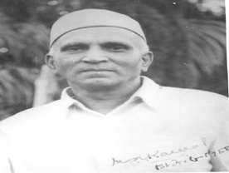
3 | Dr.V.Agnihothrudu (First Secretary)  Former Technical Advisor, M/s. Rallis India Ltd., 6-A, Cunningham Road  Bangalore – 560 052, Karnataka | 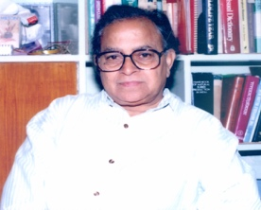
4 | Prof. K.G. Mukerji (First Treasurer)  Former Head, Dept. of Botany  University of Delhi, Delhi-110007 | 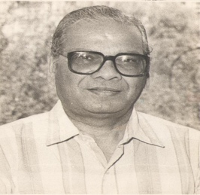
5 | Prof. K. Ramakrishnan (First Council Member)  Former Dean, University of Agricultural Sciences, Hebbal  Bangalore – 560 024, Karnataka | 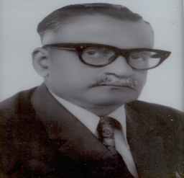
6 | Prof. T.S. Sadasivan (Second President)  Former Director,Centre for Advanced Studies in Botany  Madras University,  Chennai-600 025, Tamil Nadu. | 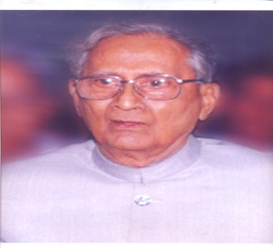
7 | Prof. T.Sreeramulu  Former Head, Dept. of Botany  Andhra University,Viskhapatnam - 530 003, Andhra Pradesh
8 | Dr. S.K. Shome  Former Asst. Director, Microbiology Division,  National Institute of Communicable Diseases  22-Sham Nath Marg, Delhi-110054 | 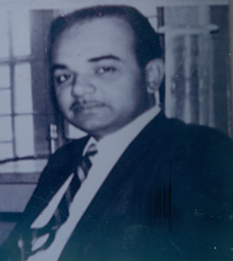
9 | Prof. K.Natarajan  Centre for Advanced Studies in Botany  Madras University, Guindy Campus  Chennai-600 025, Tamil Nadu | 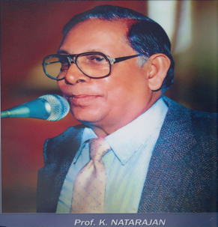
10 | Prof. R. Narayana Swamy  Centre for Advanced Studies in Botany  Madras University, Guindy Campus  Chennai-600 025, Tamil Nadu | 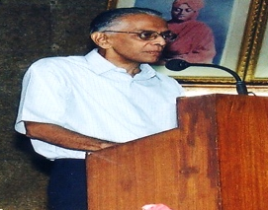
11 | Prof. P.C. Jain  Dept. of Applied Microbiology & Biotech.  Dr. HS GourVishwavidyalaya,  Sagar-470 003, Madhya Pradesh
12 | Dr.D D. Awasthi  Sector 11, H. No. 34 Indira Nagar,  Lucknow-226 016, Uttar Pradesh | 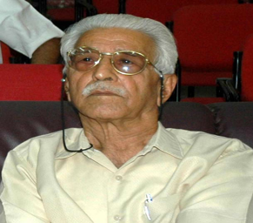
13 | Prof. C. V. Subramanian (First Editor)  Former Director,Centre for Advanced Studies in Botany  Madras University,  Chennai-600 025, Tamil Nadu. | 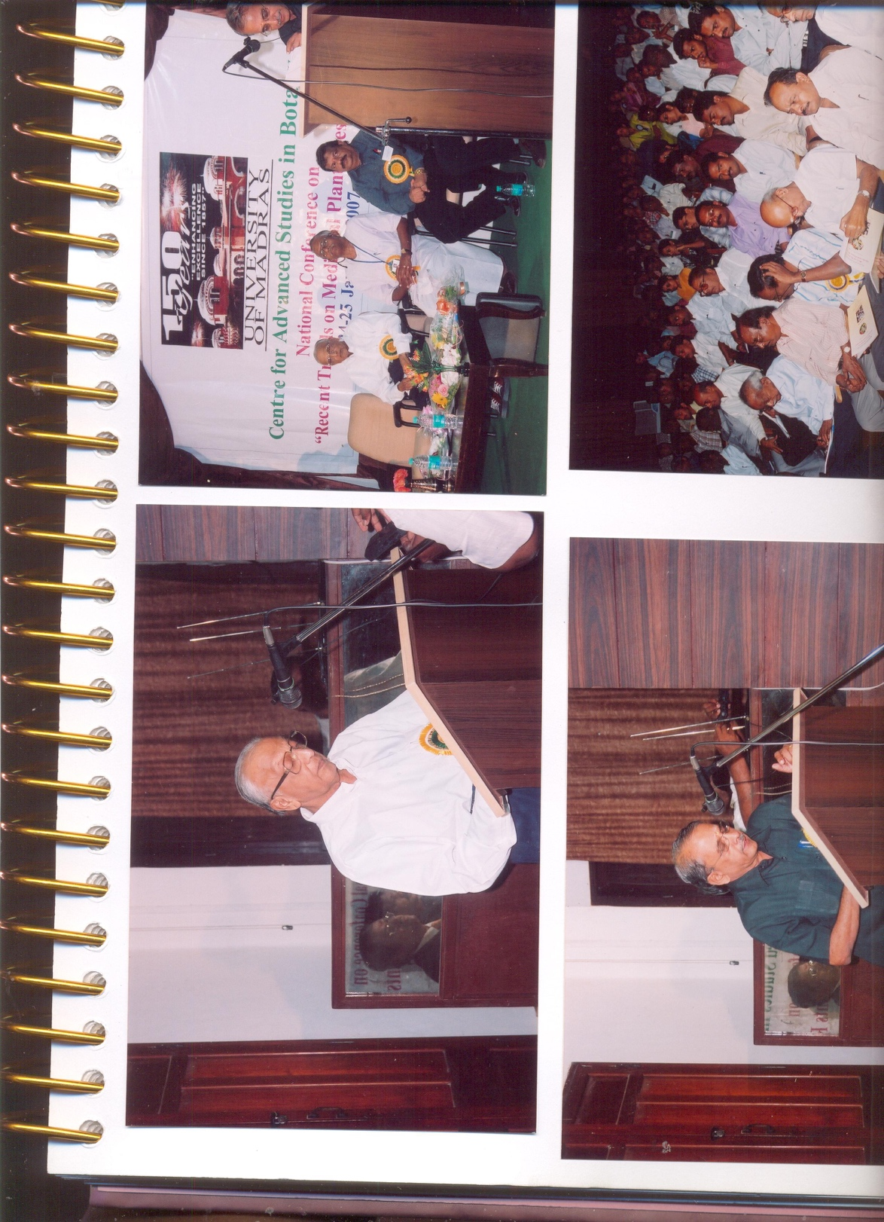
14 | Prof. B.P.R.Vittal  Centre for Advanced Studies in Botany  Madras University, Guindy Campus  Chennai-600 025, Tamil Nadu | 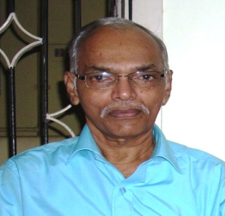
15 | Prof. J. Muthumary  Centre for Advanced Studies in Botany  Madras University, Guindy Campus  Chennai-600 025, Tamil Nadu | 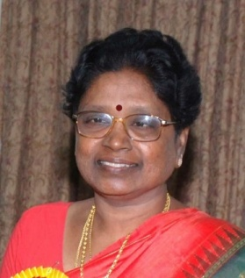
16 | Prof. T. Padmavathi  Head, Department of Microbiology, Jain University  18/3, 9th Main, Jayanagar III Block  Bangalore-560 011,Karnataka

